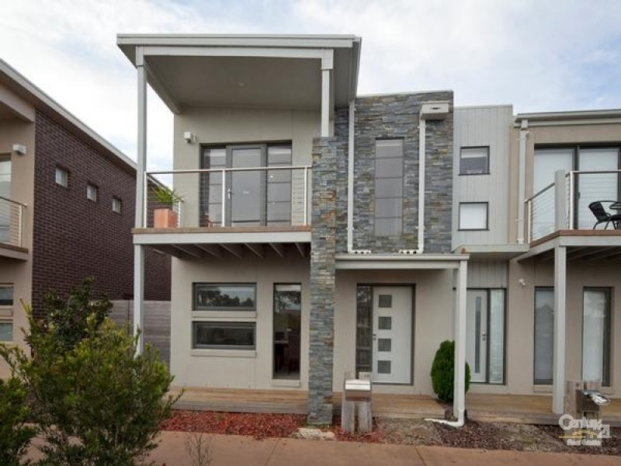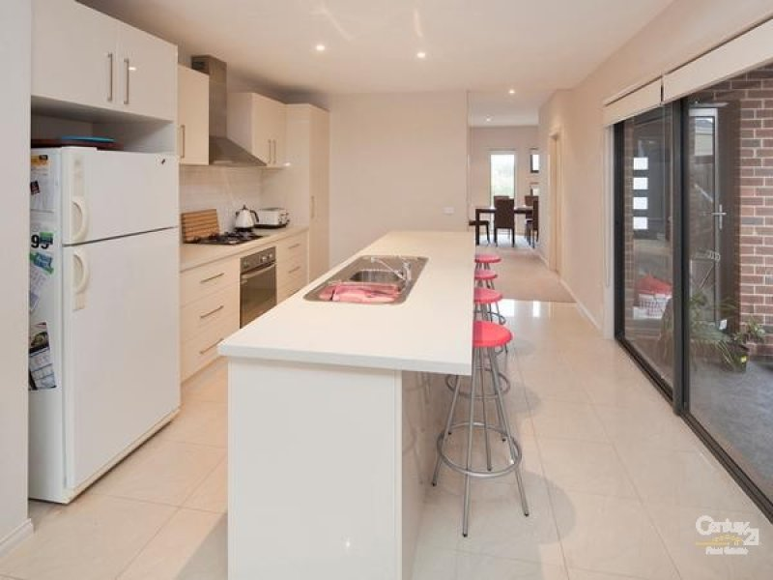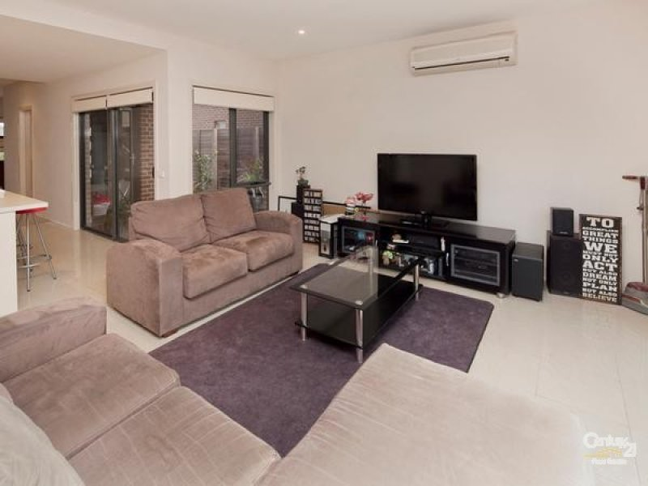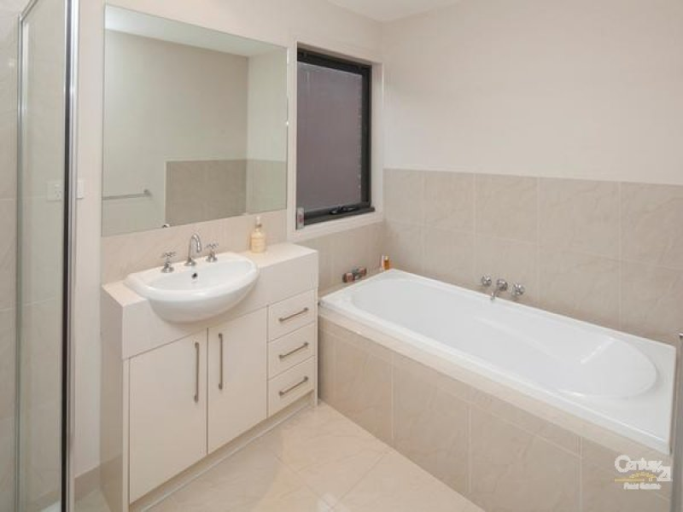- 3 bedrooms all with split system heating cooling  
- Study  
- Master with massive walk in robe, ensuite and balcony overlooking parklands  
- Kitchen with meals/family with split system heating cooling   
- 2nd living area  
- Dishwasher  
- Alfresco  
- Double garage with remote.

* $340 pw